**Digit Recognizer**

**Project Description –**

### Goal

The goal in this competition is to take an image of a handwritten single digit, and determine what that digit is. For every in the test set, you should predict the correct label.

**Metric**

This competition is evaluated on the categorization accuracy of your predictions (the percentage of images you get correct).

**Submission File Format**

The file should contain a header and have the following format:

ImageId,Label  
1,0  
2,0  
3,0

**Case Description Highlights**

They’ve curated a set of tutorial-style kernels which cover everything from regression to neural networks. We encourage you to experiment with different algorithms to learn first-hand what works well and how techniques compare.

### Practice Skills

* Computer vision fundamentals including simple neural networks
* Classification methods such as SVM and K-nearest neighbors

**Approach –**

**The approach to the problem involves the use of keras and CNN. Since each numeric digit has some characteristic that separates them from the rest, our goal will be to develop a model that can extract these features and based on their influence (weight), we can correlate them to the closest logical digit, and then provide the final output.**

**Factors Considered –**

**The factors that are considered while making the model include the key factors in each individual digit. These are recognized by the pixel values in the input data. Each pixel in the image represents some value, which is broken down in the neural network, and based on the values and weighted sum, we extract the key features of the image and then correlate them to an integer. For example, the number 7 has a distinct horizontal line and a slant line, and the number 1 has a vertical line with a small base horizontal line. So the neural network developed will be able to extract these characteristics for these numbers and map them to the logical output. The same is applicable to all other digits as well.**

**Flow and Steps –**

**In this section we shall see how the model was developed and implemented. We firstly import keras and tensorflow along with out csv files containing train and test data. Then, we filter these images to a matrix and rearrange them. These are the aspects associated with pre-processing for our Convolutional neural network. We also take a few samples from the array and test their image as a form of grey scaled version i.e., Black and white. Once this is done and verified, we can progress further towards the CNN model to train with the sample of images and run-on new images. The CNN model involves hidden layers designed in the program, to identify the features properly. They are then trained with the batch size of 329 images for 60 epochs. On the basis of this training, we obtain an accuracy and training loss shown in the next section.**

**Results –**

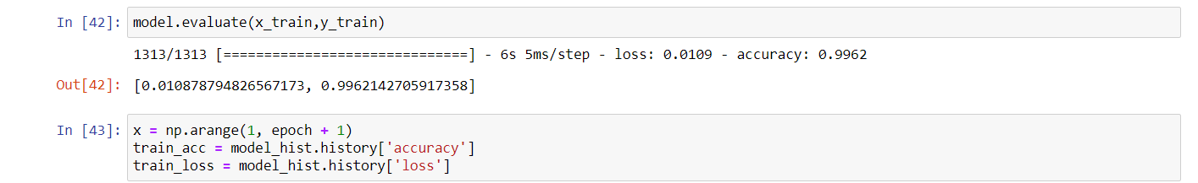

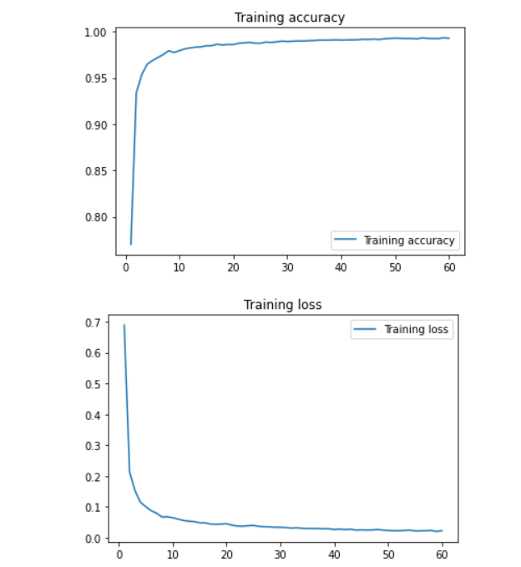

**Conclusion –**

**The results for our digit recognizer were shown above. The model is now capable of predicting handwritten digits inputted for test. For the challenge, we compile a submission file in the form of an excel sheet consisting analyzed outputs and matched with the actual digit in the image as well.**